1.BINARY CALCULATOR.

#include<stdio.h>

double arithmetic(char choice,int a,int b)

{

double ans;

switch(choice)

{

case '+':

ans=a+b;

break;

case '-':

ans=a-b;

break;

case '*':

ans=a*b;

break;

case '/':

ans=a/b;

break;

case '%':

ans=a%b;

break;

default:

ans=0.0;

printf("\n Invalid case");

}

return ans;

}

main()

{

int a,b;

double ans;

char choice;

printf("Enter choice.\n");

scanf("%c",&choice);

printf("Enter 1st number.\n");

scanf("%d",&a);

printf("Enter 2nd number.\n");

scanf("%d",&b);

printf("Your answer is->");

ans=arithmetic(choice,a,b);

printf("%lf",ans);

}

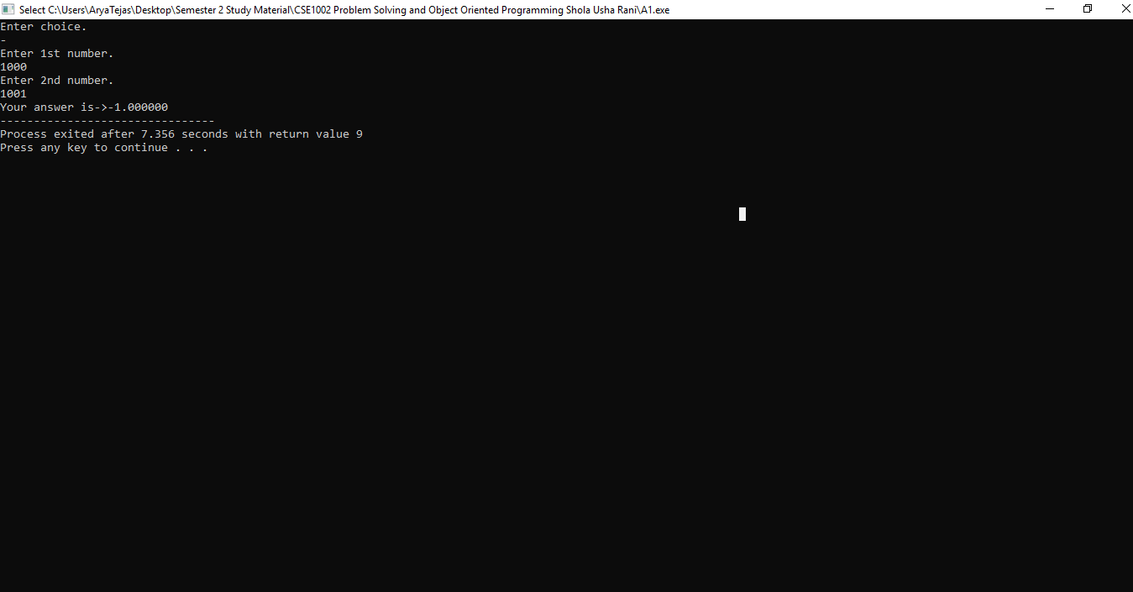

2.TO GENERATE FIBONACCI SERIES.

#include<stdio.h>

void fibonacci_series(int n)

{

int a,b,c,i;

a=0;

b=1;

printf("%d,%d,",a,b);

for(i=2;i<=n;i++)

{

c=a+b;

printf("%d,",c);

a=b;

b=c;

}

}

main()

{

int n;

printf("Enter number of terms in fibonacci series-");

scanf("%d",&n);

printf("\nFibonacci Series-");

fibonacci_series(n);

}

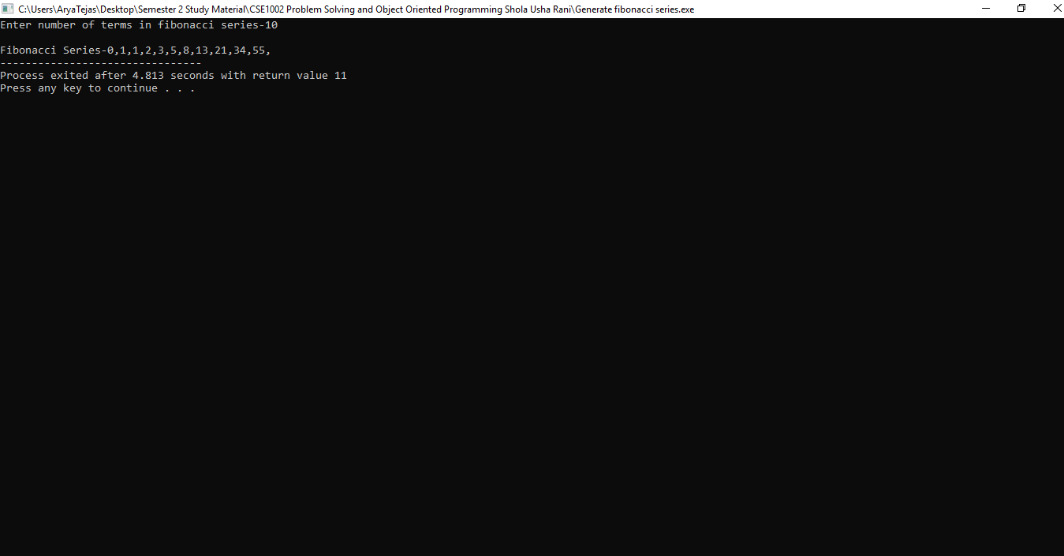

3.C PROGRAM TO FIND NUMBER OF CHARACTERS AND WORDS IN SENTENCE.

#include <stdio.h>

#include <string.h>

main()

{

char str[50];

int i=0, word=0, chr=0;

printf("\nEnter Your String: ");

gets(str);

while (str[i] != '\0')

{

if (str[i] == ' ')

{

word++;

chr++;

}

else

chr++;

i++;

}

printf("\nNumber of characters: %d", chr);

printf("\nNumber of words: %d", word+1);

getch();

